**LAB ASSIGNMENT-3.4**

**Task 1: Zero-shot Prompt – Fibonacci Series Generator**

**Task Description #1**

• Without giving an example, write a single comment prompt asking GitHub Copilot to generate a Python function to print the first N Fibonacci numbers.

**Expected Output #1**

**•** A complete Python function generated by Copilot without any example provided.

• Correct output for sample input N = 7 ➝ 0 1 1 2 3 5 8

• Observation on how Copilot understood the instruction with zero context.

**Prompt:** Generate a Python function to print the first N Fibonacci numbers with user input.

**CODE & OUTPUT:**

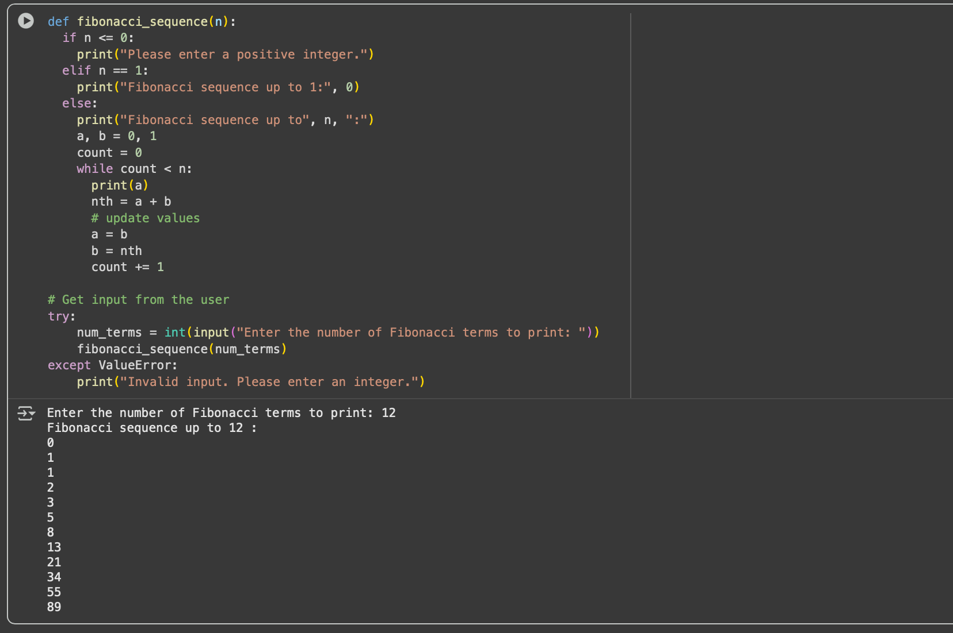**T:**

**Task 2: One-shot Prompt – List Reversal Function**

**Task Description #2**

• Write a comment prompt to reverse a list and provide one example below the comment to guide Copilot.

**Expected Output #2**

• Copilot-generated function to reverse a list using slicing or loop.

• Output: [3, 2, 1] for input [1, 2, 3]

**PROMPT :** generate a python code for reverse of a list using slicing or looping for example [1,2,3,4,5] output:[5,4,3,2,1]

**CODE & OUTPUT:**

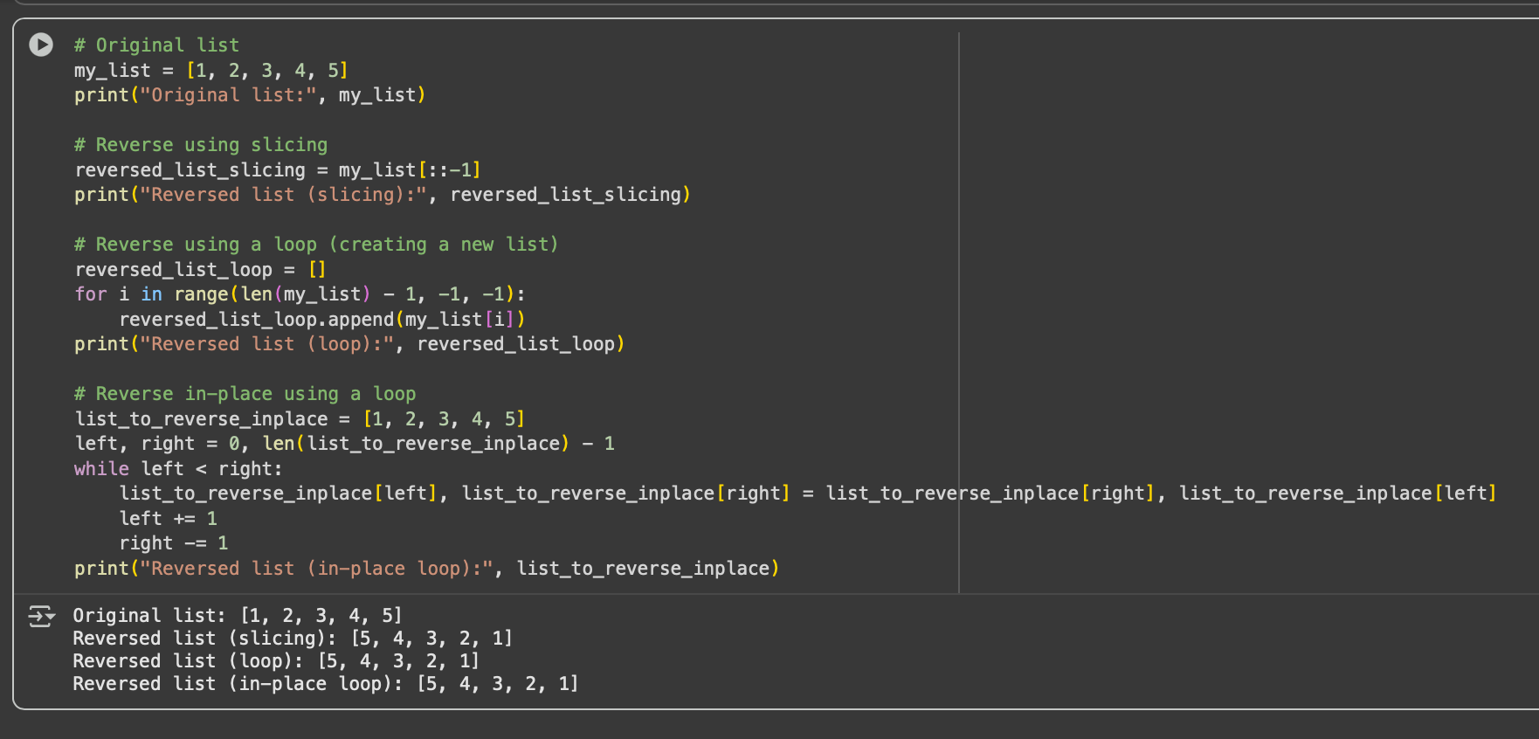

**Task 3: Few-shot Prompt – String Pattern Matching**

**Task Description #3**

• Write a comment with 2–3 examples to help Copilot understand how to check if a string starts with a capital letter and ends with a period.

**Expected Output #3**

• A function is_valid() that checks the pattern.

• Output: True or False based on input.

• Students reflect on how multiple examples guide Copilot to generate more accurate code.

**Prompt :**

generate python function is_valid() to Check if a string starts with a capital letter and ends with a period.

**CODE & OUTPUT:**

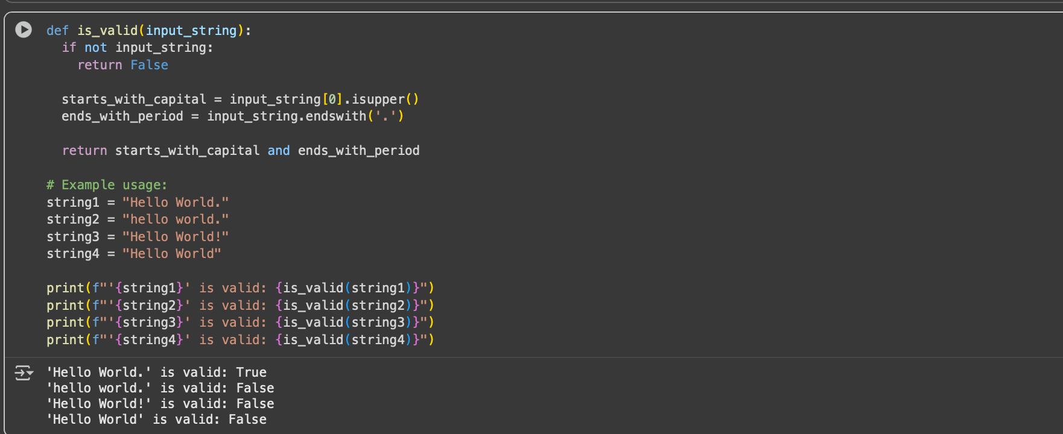

**PROMPT-2:**

Generate python function is_valid() to Check if a string starts with a capital letter and ends with a period. Examples: "Hello." -> True "hello." -> False (starts with lowercase) "Hello!" -> False (does not end with a period) "Good morning." -> True "Good morning" -> False (no ending period).

**CODE&OUTPUT:**

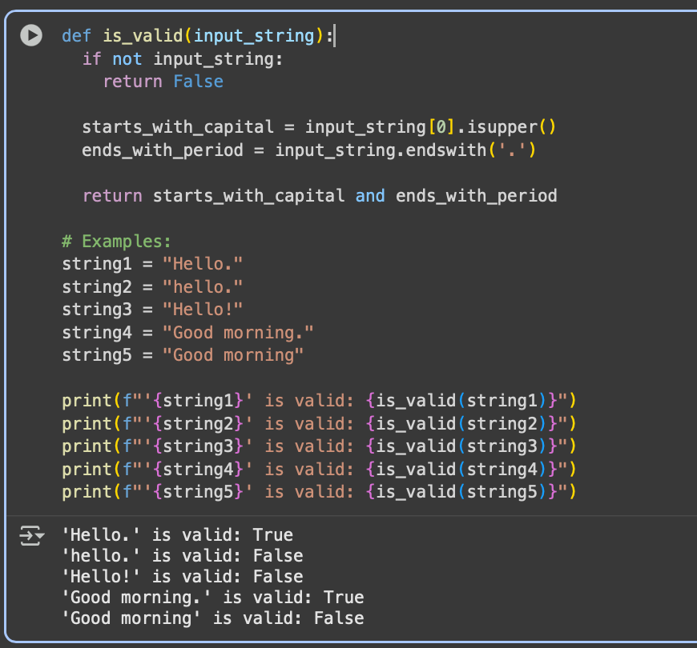

**Task 4: Zero-shot vs Few-shot – Email Validator**

Task Description #4

• First, prompt Copilot to write an email validation function using zero-shot (just the task in comment).

• Then, rewrite the prompt using few-shot examples.

**Expected Output #4**

• Compare both outputs:

Zero-shot may result in basic or generic validation.

Few-shot gives detailed and specific logic (e.g., @ and domain checking)

PROMPT-1:

write an python email validation function.

CODE&OUTPUT:

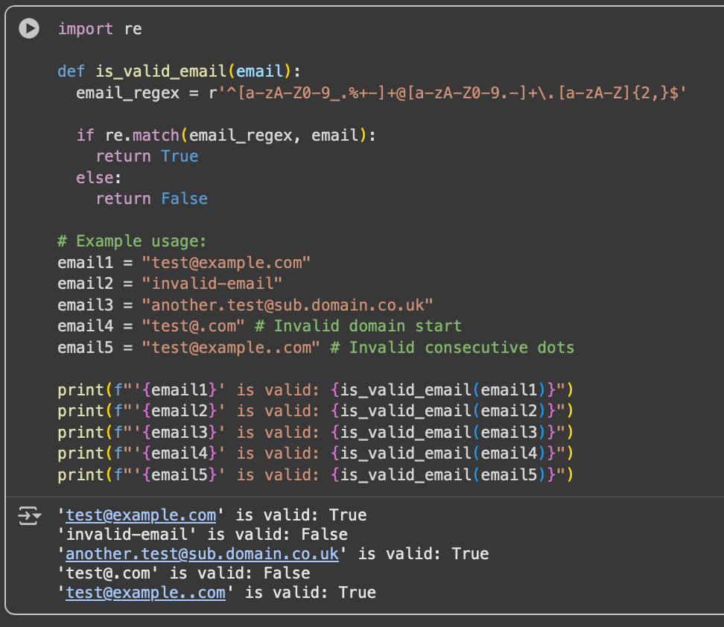

**Task 5: Prompt Tuning – Summing Digits of a Number**

**Task Description #5**

• Experiment with 2 different prompt styles to generate a function that returns the sum of digits of a number.

Style 1: Generic task prompt

Style 2: Task + Input/Output example

**Expected Output #5**

• Two versions of the sum_of_digits() function.

• Example Output: sum_of_digits(123) ➝ 6

• Short analysis: which prompt produced cleaner or more optimized code and why?

**PROMPT:**

generate a function that returns the sum of digits of a number.

CODE&OUTPUT:

